SOUTH AFRICA – Limpopo / NW Since 1994

 DG & PG Special Safari 
Observer: $180 / £140 / €165 per Night
6 Trophy Species = 14 days / 13 nights $24,000

Buffalo (<42”)  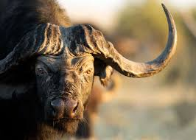 | Nyala  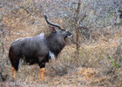 | Bushbuck (L)  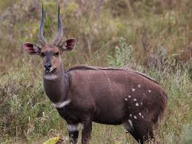
Red Hartebeest  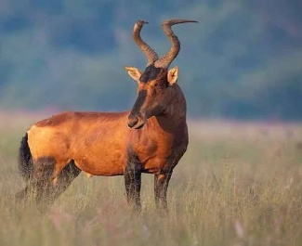 | Black Impala  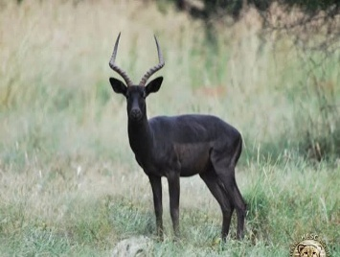 | Lechwe  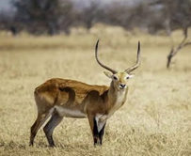

Package Include:
Airport pick-up / drop-off plus all ground transportation during the stay, Day / Hunter Fees,
Trophy Fees, Hunting permits / Concession Fees, Services of a Professional Hunter, Tracker/s &
Skinner/s, Hunting vehicle, Field preparation of Trophies & Delivery to the local Taxidermist,
All meals, Accommodation, Drinks, Alcohol, Local Wine & Beer (in moderation).



