SOUTH AFRICA – Limpopo / NW Since 1994

 DG & PG Special Safari 
Observer: $180 / £140 / €165 per Night
8 Trophy Species = 14 days / 13 nights $32,500

Buffalo (<42”)  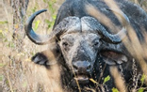 | Sable (<42”)  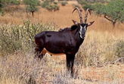 | Roan (<28”)  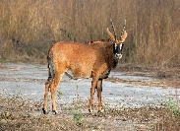 | Kudu (<55”)  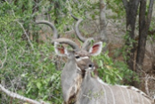
Waterbuck  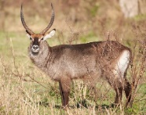 | Nyala  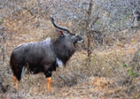 | Impala  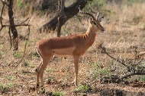 | Bushbuck (L)  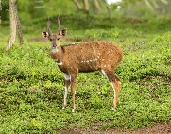

Package Include:
- Airport pick-up / drop-off plus all ground transportation during the stay.
- Day / Hunter Fees.
- Trophy Fees.
- Hunting permits / Concession Fees.
- Services of a Professional Hunter, Tracker/s & Skinner/s, Hunting vehicle.
- Field preparation of Trophies & Delivery to the local Taxidermist.
- All meals.
- Accommodation.
- Drinks, Local Wine & Beer (in moderation).



