SOUTH AFRICA – Limpopo / NW Since 1994

 DG & PG Special Safari 
Observer: $180 / £140 / €165 per Night
6 Trophy Species = 12 days / 11 nights $18,550

Buffalo + Kudu
Buffalo (<42”)  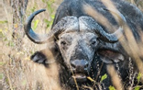 | Kudu (<55”)  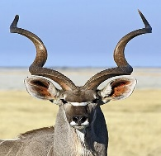

PLUS + any 4
Springbuck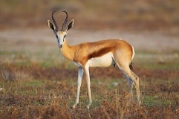 | Impala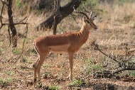 | Blesbuck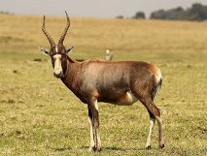 | Warthog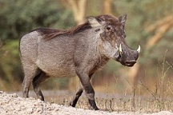 | Duiker  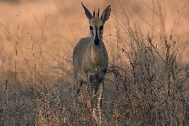 | Steenbuck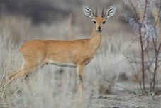
Package Include:
- Airport pick up & drop off | - Day / Hunters Fees | - Trophy Fees
- All Meals | - Accommodation | - Local beer & Wine (in moderation)
- Services of Professional Hunter, Tracker/s & Skinner/s, Hunting Vehicle
- Field preparation of Trophies & Delivery to the local Taxidermist



