SOUTH AFRICA – Limpopo Since 1994

 DG & PG BOW hunt Safari 
Observer: $180 / £140 / €165 per Night
4 Trophy Species = 10 days / 9 nights $14,699 / £11,500 / €13,899

Buffalo + Giraffe
Buffalo  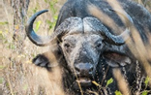 | Giraffe  

PLUS + any 2
Springbuck  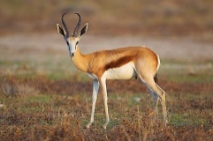 | Impala  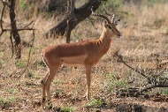 | Blesbuck  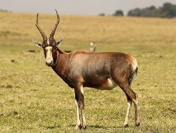 | Warthog  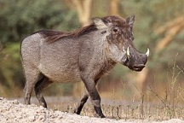
Package Include:
- Airport pick up & drop off | - Day / Hunters Fees | - Trophy Fees
- All Meals | - Accommodation | - Local beer & Wine (in moderation)
- Services of Professional Hunter, Tracker/s & Skinner/s, Hunting Vehicle
- Field preparation of Trophies & Delivery to the local Taxidermist



